**Fearnhead Cross Medical Centre & Longford Street Surgery**



***HEALTH CARE FOR YOU AND YOUR FAMILY***

**Longford Street Surgery**

**Longford Street**

**Warrington**

**Cheshire**

**WA2 7QZ**

**Tel: 01925 255600 Fax: 01925 634954**

**Fearnhead Cross Medical Centre**

**25 Fearnhead Cross**

**Warrington**

**Cheshire**

**WA2 0HD**

**Tel: 01925 847000 Fax: 01925 818650**



**Practice Website -** [**www.fearnheadcrosssurgery.co.uk**](http://www.fearnheadcrosssurgery.co.uk)

**How to contact us:**

**Telephone:**

Fearnhead Cross Medical Centre – 01925 84700

Longford Street Surgery – 01925 255600

Option 1 – Reception queries

Option 2 – Prescription queries

Option 3 – Home visit requests

Option 4 – Test Results

Option 5 - Secretary

**Opening hours:**

Monday – 8.00 – 6.30

Tuesday – 8.00 – 6.30

Wednesday – 8.00 – 6.30

Thursday – 8.00 – 6.30

Friday – 8.00 – 6.30

**Social media:**

We update our social media pages with updates to our services & information we think may be useful to our patients.

Website – [www.fearnheadcrosssurgery.co.uk](http://www.fearnheadcrosssurgery.co.uk)

Facebook - **Fearnhead Cross Medical Centre & Longford Street Surgery**

We offer an online consultation service called PATCHS. This can be found on our Practice website: **www.fearnheadcrosssurgery.co.uk**



Prescription email address:

**cmicb-war.fearnheadcrossfax@nhs.net**

**Out of hours treatment and advice:**

**For all life-threatening emergencies call 999**

For non-emergency medical treatment or medical advice when we are closed you can:

* Visit a walk-in centre (our nearest Walk in Centre’s are Leigh WNR 1HR or Widnes WA8 7GD
* Call 111 or fill out an online form on the NHS 111 website: **https://111.nhs.uk/**

**Our Practice Team**

**GP Partners:**

**Senior Partner**

**Dr Edward Philip Martin Taylor** (Male)

MBChB DRCOG MRCGP

**Dr Golam Chowdhury** (Male)

MB BS

**Dr Dawn Tragen** (Female)

MBChB

**Dr Shobha Ramesh** (Female)

MBBS, MRCP, MRCGP, DFFP, Dip Occ

**Salaried GP’S**

**Dr Sanaa Khalil** (Female) MBBS, MRCP

**Dr Sara Nasir (Female)**

Salaried GP MBBS

**Dr Shanti Natarajan (Female)**

Salaried GP MBBS, DFFP, MRCGP, MSc Diabetes

**Dr Lavanya Villuri** (Female)

Salaried GP MBBS, MRCGP, DRCOG

**Salaried GP**

**Dr D Walton**

**Dr Khalil**

**Dr Silva**

**Locum GP**

None

**Gail Shelley - Advanced Nurse Practitioners (ANP)**

“Advanced Nurse Practitioners are Registered Nurses who have **done extra training and academic qualifications** to be able to examine, assess, make diagnoses, treat, prescribe and make referrals for patients who present with undiagnosed/undifferentiated problems”

**Management Team**

Practice Manager – Mrs Nicola Golding

Associate Managers – Mr Joe Dugdale and Miss Ellie Stott

**Practice Nurses**

**Sister Andrea Porter** – RGN – Andrea has a special interest in respiratory care and also holds minor ailment clinics where she treats patients for acute conditions such as sore throats, ear infections and chest infections.

**Sister Shireen Spencer** – RGN - Shireen has a special interest in women's and sexual health and runs our coil and contraceptive implant clinics.

Shireen and Andrea Shireen are independent nurse prescribers, meaning they can prescribe for several chronic conditions including Asthma and COPD.

**Sister Susie Schofield** – RGN – Susie has a background in and end of life care and has a special interest in this and will also be holding appointments for diabetic reviews.

**Pharmacy Team**

**Matthew Cockcroft** – Matthew is one of our diabetic leads and carries out most of our diabetic reviews. He is also trained in treating and prescribing for minor ailments such as coughs, sore throats, and earaches.

**Jessica Dodd** – Jessica has a special interest in research and is a member of the practice research team. Jessica is also trained and treating for minor ailments.

Matt and Jess are the first point of contact for medication queries; they run weekly medication review clinics for patients to book into. They also work through any letters we receive from our colleagues to ensure patients medication lists are up to date. I.e. if you have had a medication change from the hospital, one of our pharmacists will add this to your medical record

**Health Care Assistants**

**Mrs Pamela Hobden**,

**Mrs Kathleen Stone,**

**Mr Adrian Banach**.

Our HCA’s are responsible for blood taking, blood pressure checks, ECG’s, flu vaccinations, shingles vaccinations & pneumonia vaccinations.

The GPs, Clinicians and Management Team are all supported by, 2 Associate Managers, 5 Administrators and 13 Reception Staff, who all help The Practice to run as smoothly as possible.

Fearnhead Medical Centre is part of the East PCN. This means that we work collaboratively with other practices to offer a wide range of services.

East PCN is built up of Fearnhead Cross Medical Centre, Padgate Medical Centre & Birchwood Medical Centre

**Training**

We are considered a training practice as we help, support & train medical students and GP Registrars.

**Medical Students -** The Practice undertakes the training of 4th & 5th year Medical Students from Liverpool University

**GP Registrars** - GP registrars, are fully qualified and registered doctors.

They are currently on a 3-year GP registration course, this involves further hospital medical training in specialties which may include paediatrics, geriatrics, psychiatry, dermatology and general medicine etc. and an attachment to a practice under a supervising qualified GP. All doctors must undergo this training before they can become fully qualified General Practitioners.

You may be offered an appointment with a Registrar; the Registrar will carry out your consultation and have a GP’s time blocked off to consult with them if required.

**Extended Colleagues**

**Community Matron**

Community matrons are **highly experienced, senior nurses who work closely with patients** (mainly those with a serious long term condition or complex range of conditions) in a community setting to directly provide, plan and organise their care.

**District Nurses** are based at The Orford Jubilee Hub and The Wolves. We no longer offer a Treatment Room Service on the premises. If you need any procedure such as dressings or removal of stitches etc carrying out, you need to call the District Nursing Team on 01925 251463 and they will make your appointment for you

**Health Visitors** – Give advice and monitor the health and development in children and their families. Health Visitors can be contacted on 01925 251530

**Community Midwives** – Provide care and advice during pregnancy and after childbirth. To self-refer to the midwife please visit: <https://whh.nhs.uk/services/maternity/pregnant-self-refer-us-filling-out-online-form-here>

**IAPT –** a Psychological therapist will be working at the Surgery to help & support our patients.

**Physiotherapist** – who can help patients presenting with musculoskeletal problems.

**Mental Health Practitioner** –they work at the Surgery each week and provide psychological support to our patients.

**Social Prescriber** – they connect people to community groups and statutory services for practical and emotional support

**Care Co-ordinator -** supports patients with mild to severe frailty within the community, they create a patient-centred care plan and provide access to support services within the local area that are most appropriate for you

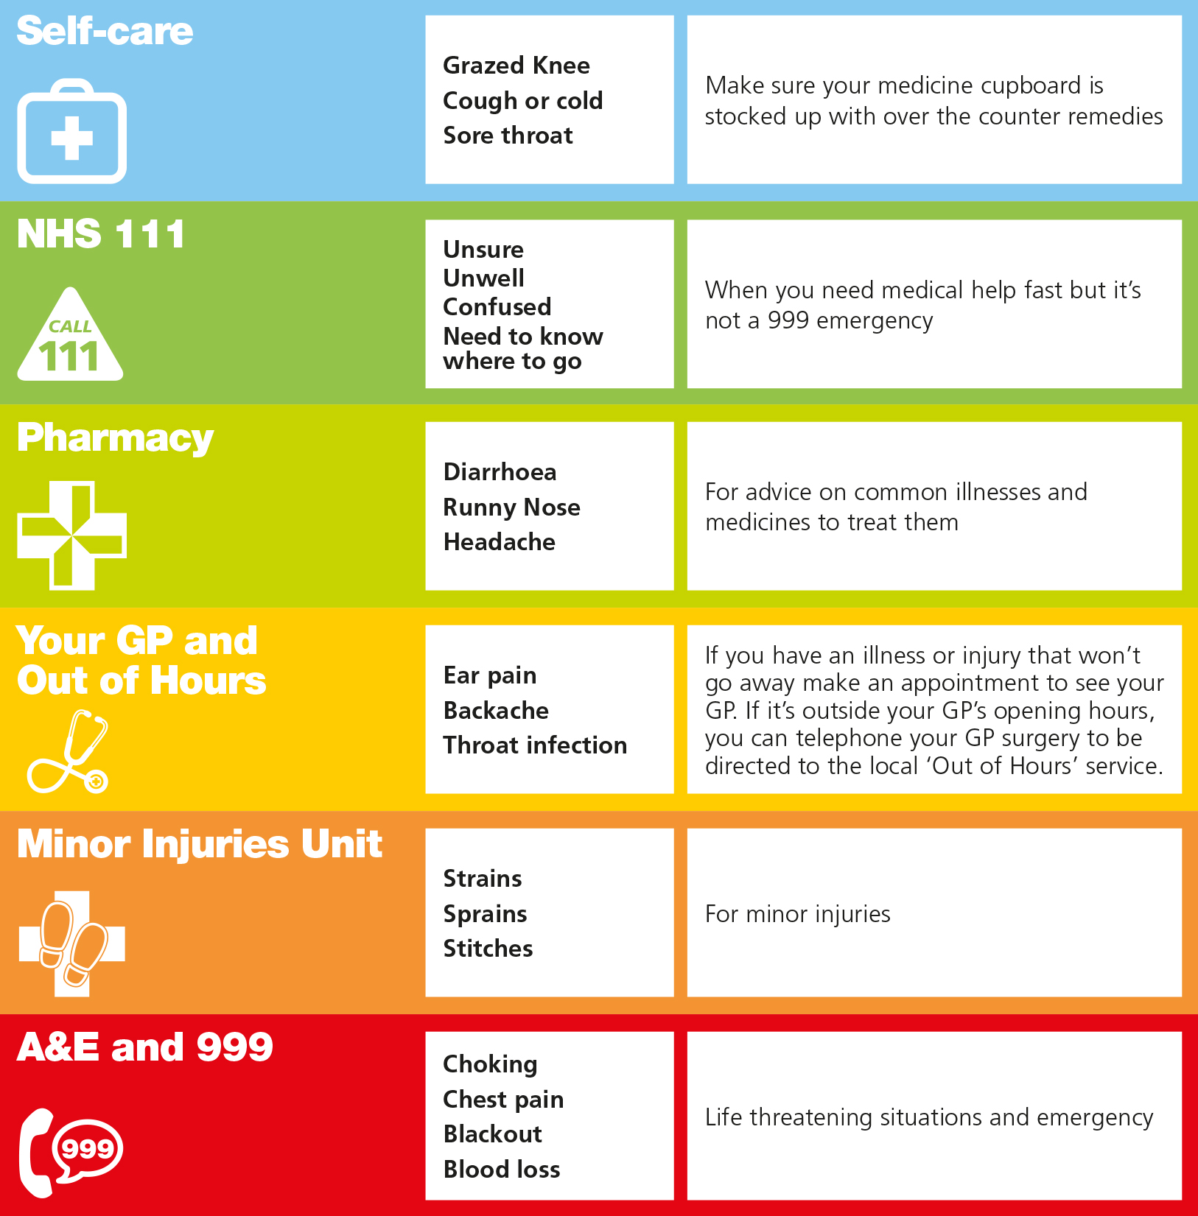

**Choosing the right treatment:**

**Appointment System:**

**Need an urgent on the day appointment?**

Please call the Surgery as close to 8.30am as you can, if you press option 1 you will be put through to a receptionist.



For routine concerns only

This is an online service that is available online Monday – Friday and allows you to contact your GP for help and advice. It will ask you to fill out a form asking you questions about your condition or symptoms.

You can find PATCHS on our website: **www.feanheadcrosssurgery.co.uk**

**Patients are able to make a pre-bookable appointment with a GP or Nurse Clinician up** **to four weeks in advance**.

All Practice Nurse & Health Care Assistant appointments are pre-bookable and can be booked up to four weeks in advance.

**Online Services:**

You can book all our pre-bookable appointments online through an online service called Patient Access. You will need to register for an account and can do this by bringing photo ID and an email to Reception. Examples of what you can book online is:

* Smear Tests
* Asthma reviews
* Contraceptive reviews
* Medication reviews
* Blood Pressure checks
* GP appointments



**Home Visits:**

Requests for Home Visits should be made by 10.30am where possible. The Receptionist will take your details & pass these onto a Clinician who will triage you.

Home visits are for patients whose physical condition makes it impossible for them to come to surgery. We do not undertake home visits for social reasons i.e. lack of transport.

**TO REDUCE THE WASTE OF A CLINICIANS TIME, WE WOULD LIKE TO REMIND PATIENTS TO CANCEL ANY APPOINTMENT THAT THEY CANNOT ATTEND. When we are closed, you can also cancel an appointment by using the ‘contact us page’ our website up to 24 hours before your appointment.**

**Temporary Residents** – Permanent residents of the UK can see an NHS Doctor anywhere in the UK if you are away from home and in need of urgent medical help. You can do this by asking to see the nearest Doctor as a temporary resident. We will be happy to see any relatives or friends staying with you if they need to see a Doctor but please be aware that **visitors to the** **UK from NON EU countries will be seen as a Private Patient which will incur a standard charge. Please ask at reception**

**Registering as a Patient**

If you wish to register as a patient, please go to either one of our surgeries and complete a patient registration form. As we are family Doctors, we prefer that all members of the family register with the Practice, as this provides the Surgery with a complete history of the patients and family circumstances. Patients have the right to express a preference of Practitioner; however, it may not always be possible to see their preferred Doctor at short notice.

You will also be asked to complete a short New Patient questionnaire and book a New Patient Registration Check with the Health Care Assistant. This enables us to have some medical history about you until we receive your medical records from your previous GP. Pre-registration forms and New Patient Questionnaires are also available to complete online on our surgery website [www.fearnheadcrosssurgery.co.uk](http://www.fearnheadcrosssurgery.co.uk)

When registering, we ask for you to bring two forms of identification with you, one of them being photographic. If you cannot supply these at the time you can still register.

Before we can you register you as a patient, we must check your address to ensure that you live within our Practice Area. A full list of our boundaries within the Warrington area is displayed in both surgeries.

**Named allocated GP** – All patients that register will have a named GP allocated to them that will be accountable for their care. It does not mean you only have to see that GP and patients can choose to see a GP of their choice. If you wish to change the GP you have been allocated, please speak to a member of the team

**Prescriptions:**

**Access**

**Disabled Access** – Both surgeries provide suitable access for disabled patients and have disabled parking spaces adjacent to the buildings. A wheelchair is available for those with difficulty in walking and this can be obtained through our Reception team. Please speak to our Reception team if you have any further requirements

**Dogs** – All dogs, except for assistance dogs, should be left outside the building

**Smoking and Food** – Both buildings are non-smoking buildings and we request that this be honoured. This includes electronic cigarettes

We would also request that patients do not eat or drink whilst waiting for their appointments. A cup of water may be obtained from Reception on request

How to request a repeat prescription:



Post your request to the Surgery

If it is more convenient, you can post your address to the Surgery:

**Fearnhead Cross Medical Centre**

**25 Fearnhead Cross**

**Warrington**

**Cheshire**

**WA2 0HD**



Bring a written request to the Surgery.

There is a letterbox outside both buildings for you to put your request.



By email: **cmicb-war.fearnheadcrossfax@nhs.net**

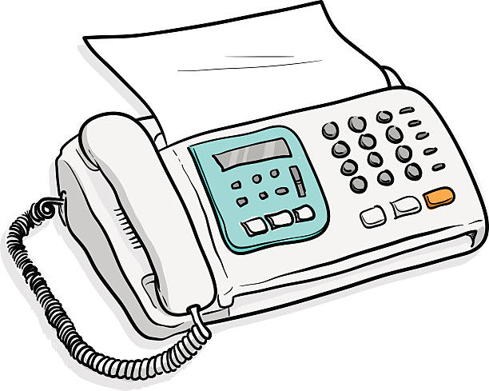

By fax:

Fearnhead – 01925 818650

Longford Street – 01925 634954



Online Services:

Patients can register for on-line access by calling into the Surgery and registering for the scheme. The receptionist will need to see photographic identification to process the request and will print out registration details for you.

Once registered patients can book and cancel appointments, order repeat medication, and view your medical records through a secure website.

**Prescription requests received BEFORE 2pm will be ready for collection AFTER 5pm 48 hours later i.e. Prescriptions ordered before 2pm on Mondays will be ready for collection after 5pm on Wednesdays**

**Please allow extra time at Bank Holidays and Weekends**

**Electronic Prescription Service (EPS)**

**We now use EPS 4**

This means that we will no longer print prescriptions for you to collect, all prescriptions will now go electronically to your nominated chemist.

If you have not nominated a chemist which is convenient for you to collect your medication, please contact the Surgery and our prescription team will set this up for you.

For those of you who have a nominated chemist, nothing should change, and you should follow your normal process in going to collect your medication from them.



**Prescription requests cannot be taken over the telephone.**



**Patient Participation Group**

The practice has a PPG (Patient Participation Group) who aim to gather feedback and views from the wider patient population about the services on offer and how patients can be involved in shaping the practice. The group are a friendly bunch who meet quarterly at Fearnhead Cross and are always on the look-out for new members. If you are interested or would like more information on what the group do, please contact Nicki Golding at the surgery.

**Complaints or Concerns**

We aim to provide the best care we can but sometimes we may fall short of the mark. Initially we would encourage you to speak to whoever you feel most comfortable with, a GP, Nurse, Manager or Receptionist.

However, if you have a complaint to make, please do not be afraid of telling us how you feel. We welcome feedback on all our services and staff to help us improve where necessary. We will do our best to put right anything that has gone wrong.

If you would prefer to put your concerns in writing, the following designated persons will ensure that it is dealt with promptly by a member of our Management Team

Responsible Person: Dr Edward Taylor

Complaints Manager: Mrs Nicola Golding

**Comments and Suggestions**

We welcome positive feedback and suggestions on how we can improve our service. There is a suggestion box on reception at both surgeries for this purpose. The practice also conducts Friends and Family surveys and a form can be collected from Reception or you will be asked to participate if you have signed up to our text messaging service.

**Patients Charter**

The Doctors, Nurses, administration staff and receptionists at this Medical centre are committed to working together to provide the best possible care for you our patient. However we need you to work together with us to achieve this aim.

You have an important role in the Partnership of care that exists between us. If you accept the responsibility as a patient, we can help you get the most from the medical care that is available to you here.

In the same way that you have the right to join the Practice of your choice, we have the right to remove patients from our list if we feel that the Doctor-Patient relationship has broken down.

**Responsibilities of the Patient**

* To treat us with the same courtesy and respect as you expect to receive
* To read the Practice Information Leaflet which can be accessed online via the surgery website
* To tell us as soon as possible if you cannot attend an appointment
* To ask for a Home visit only if it is not possible to come to surgery
* To allow sufficient time for your prescription to be processed
* To be understanding if the surgery is running late
* To tell us if you change your address or phone number
* Not to ask for another member of the family to be seen at your appointment

**We Undertake**

* To show courtesy to you as an individual and respect your rights to confidentiality and privacy
* To ensure that you receive the most appropriate care by suitably qualified staff
* To make sure that you receive a clear explanation of the proposed treatment and an opportunity to ask any questions
* To provide information about the services available at the Practice
* To see patients who feel their illness requires attention the same day
* To involve you in decisions regarding your health care, treatment and investigations
* To strive to improve the services that we offer. If you have any suggestions, they should be addressed to the Practice Manager, Mrs Nicola Golding or put into the suggestion box on the reception desk at both surgeries

**Practice Policy for removing patients from our list**

If it is felt that a GP – Patient relationship has irretrievably broken down, The Practice reserve the right to remove the patient from the Practice list. This would only be done in the most extreme cases and is not a decision the GPs take lightly. Before any removal is considered, the following steps will be taken:

* The Practice will issue a written warning to patients who are at risk of removal from the practice list detailing the reasons for this and offering a chance to discuss what is happening
* The Practice can remove a patient from the list if the written warning has taken place within a 12 month period prior to the date or the removal request

**Exceptions to the above are**:

* If the removal relates to a change of address
* If the GPs have reasonable grounds for believing that issuing such a warning would be harmful to the physical or mental state of the patient
* If the removal would put at risk the safety of members of staff or patients and public at the practice
* Where, in the GPs opinion, it would not otherwise be reasonable or practical to give such a warning

**Removal from our list will not be based upon any of the following grounds:**

* Race
* Gender
* Social Class
* Age
* Religion
* Sexual Orientation
* Appearance
* Disability
* Medical Conditions
* Need for specific treatments
* Relationship to a patient already removed from the list

**Abusive Behaviour**

We operate a zero tolerance – Verbal Abuse, aggression or violence to NHS staff is UNACCEPTABLE. It is Practice Policy to prosecute any person displaying such behaviour and The Practice will immediately remove any patient from the list if they do so

**How We Use Your Information**

This leaflet briefly explains why the doctor’s surgery collects information about you, and how that information may be used.

The health care professionals who provide you with care maintain records about your health and any treatment or care you have received previously (e.g. NHS Trust, GP Surgery, Walk-in clinic, etc.). These records help to provide you with the best possible healthcare.

Records may be held in electronic or manual (written down) format, and may include the following information;

* Details about you, such as address and next of kin
* Any contact the surgery has had with you, such as appointments, clinic visits, emergency appointments, etc.
* Notes and reports about your health
* Details about your treatment and care
* Results of investigations, such as laboratory tests, x-rays, etc.
* Relevant information from other health professionals, relatives or those who care for you and know you well

To ensure you receive the best possible care, your records are used to facilitate the care you receive. Information held about you may be used to help protect the health of the public and to help us manage the NHS. Information may be used for clinical audit to monitor the quality of the service provided. Where we do this, we take strict measures to ensure that individual patients cannot be identified.

Some of this information will be held centrally and used for statistical purposes. Where we do this, we take strict measures to ensure that individual patients cannot be identified.

Sometimes your information may be requested to be used for research purposes – the surgery will always endeavour to gain your consent before releasing the information.

Should you have any concerns about how your information is managed at the surgery please contact the Practice Manager to discuss how the disclosure of your personal information can be limited.

**How do we maintain the confidentiality of your records?**

Every member of staff who works for an NHS organisation has a legal obligation to keep information about you confidential. Anyone who receives information from an NHS organisation has a legal duty to keep it confidential.

We always maintain our duty of confidentiality to you . We will only ever use or pass on information about you if others involved in your care have a genuine need for it. We will not disclose your information to any third party without your permission unless there are exceptional circumstances (i.e. life or death situations), or where the law requires information to be passed on.

**Who are our partner organisations?**

We may also have to share your information, subject to strict agreements on how it will be used, with the following organisations;

* NHS Trusts
* Specialist Trusts
* Independent Contractors such as dentists, opticians, pharmacists
* Private Sector Providers
* Voluntary Sector Providers
* Ambulance Trusts
* Clinical Commissioning Groups
* Social Care Services
* Local Authorities
* Education Services
* Fire and Rescue Services
* Police
* Other ‘data processors’

**Access to your Information**

You have a right under the Data Protection Act 1998 to access/view what information the surgery holds about you, and to have it amended or removed should it be inaccurate. This is known as ‘the right of subject access’. If you would like to make a ‘subject access request’, please contact the practice manager in writing.

If you would like further information about how we use your information, or if you do not want us to use your information in this way, please contact the Practice Manager.

**Important information about your health records – The NHS Care Records Service (Summary Care Records)**

The NHS in England is introducing the NHS Care Records Service to improve the way we care for patients. Every patient will have an NHS Care Record that is made up of two parts: the Summary Care Record and Detailed Records. These electronic records are supported by Warrington PCT as they are helping to deliver better, safer care for patients.

Your Summary Care Record (SCR) will be available to healthcare staff providing you with NHS care anywhere in England. At first, it will contain key health information such as details of allergies, current prescriptions and bad reactions to medicines. After that, each time you use any NHS health services details about any current health problems, summaries of your care and the professionals treating you may be added to your SCR. Your SCR will be of most benefit if you need health care in an emergency or if you are away from home in England and need treatment.

In order for staff to look at your SCR they must ask you for your permission. If the healthcare worker treating you is not able to ask for your permission (for example, if you were unconscious or unable to answer questions) they can access your record in your best interests.

If you are the parent or guardian of a child under 16 then you should make this information available to them if you feel they are old enough to understand.

It is intended that Summary Care Records will be phased in for patients over the next year, but we need to explain that you do have choices.

Dr E Taylor & Partners believe that Summary Care Records will improve the quality and safety of your care, however,if you do not want to have a Summary Care Record please ask at reception for an opt out form. If we do not receive an opt out form within 4 weeks of you registering at the practice then a Summary Care Record will be created.

If you have already opted out at your previous practice could you please inform us when you register.

**Useful Telephone Numbers**

|  |  |
| --- | --- |
| **NHS 111** | **111** |
| **District Nurses services** | **01925 251463** |
| **Health Visitors** | **01925 251520** |
| **Warrington NHS Trust Hospital** | **01925 635911** |
| **Hollins Park Hospital** | **01925 655221** |
| **Social Services** | **01925 444000** |
| **St. Rocco’s Hospice** | **01925 573105** |
| **Warrington Police** | **101 non-urgent**  **999 for emergencies** |
| **Samaritans** | **01925 638808** |

**PALS – Advice and Support**

**Patient Advice and Liaison Services (PALS).** It is available to assist with any concerns you may have with the healthcare you are receiving and can help resolve problems or provide independent advice. The PALS service aims to:

* Advice and support patients, relatives and carers
* Provide information on NHS services
* Listen to your concerns, suggestions or queries
* Help sort out problems quickly on your behalf
* Refer you on to external organisations where appropriate

However, PALS does not replace the formal NHS Complaints Procedure **The PALS officer for Warrington and Halton Hospitals can be contacted on  01925 275512 Email:**[**PALS@whh.nhs.uk**](mailto:PALS@whh.nhs.uk)and is based at Warrington Hospital